**Project Design Phase**

**Solution Architecture**

|  |  |
| --- | --- |
| Date | 15 February 2025 |
| Team ID |  |
| Project Name |  |
| Maximum Marks | 4 Marks |

**Solution Architecture:**

1. **Find the best tech solution** to solve problems like late diagnosis, fragmented data, and lack of real-time support.
2. **Describe the behavior and structure** of the AI healthcare system for all stakeholders (patients, hospitals, developers).
3. **Define key features** such as:
   * Symptom-based disease prediction
   * Health report analysis using OCR
   * Treatment suggestions
   * Dashboard and analytics for doctors
4. **Provide development guidelines** including tools like Flask, Machine Learning models, OCR engines, and APIs.

**Example - Solution Architecture Diagram:**

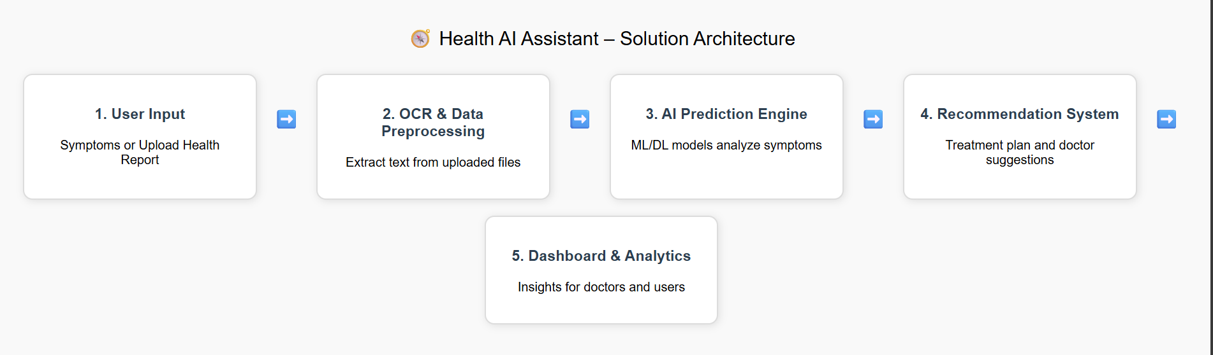

*Figure 1: Architecture and data flow of the voice patient diary sample application*

**Reference:** [**https://aws.amazon.com/blogs/industries/voice-applications-in-clinical-research-powered-by-ai-on-aws-part-1-architecture-and-design-considerations/**](https://aws.amazon.com/blogs/industries/voice-applications-in-clinical-research-powered-by-ai-on-aws-part-1-architecture-and-design-considerations/)